30.49: a) Series: 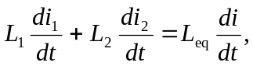
but 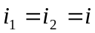for series components so 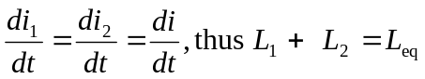
b) Parallel: Now 